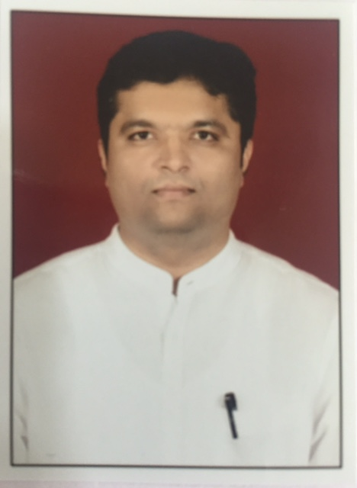

**Dr. Nijamuddin Abdul Jabbar Kotwal**

**Specialist Physician [ Internal Medicine]**

**PERSONAL INFORMATION**

**DOB:** 29/07/1982 **Marital Status:** Married

**Nationality:** Indian **Gender :** Male

**Address**: B. No.68/70 **E:** niza97@rediffmail.com

Dr. Kotnis Nagar **Tel:** (M) +91 9168206060

Vijapur Road +91 9881103070

Solapur, Maharashtra

413004, India skype Id – niza97_2

**CAREER PROFILE**

nijamuddin Kotwal ,

As a Consultant Physician with over five years of expereince, I have the ability to work well on my own initiative and can demonstrate the higher level of work. I am devoted for my profession. I perform effectively even with in highly pressurized working environment. I enjoy clinical and management responsibilities and see myself as an effective leader who is able to identify need, implement change and motivate a team.

**EDUCATION**

**M.B.B.S**

# 19/07/1999 - 20/12/2003

# Krishna Institute of Medical Sciences, Karad, Dist. Satara. Maharashtra, India

# Maharashtra University of Health Sciences, Nashik

**Compulsory Rotational Internship Program**

01Jan 2004 to 31 Dec 2004

Krishna Hospital attached to KIMS Karad

1100 bedded hospital with 7 different ICU’s and 28 different wards

**D.N.B . Internal Medicine**

02/08/2006 - 01/08/2009

Ashwini Sahakari Rugnalaya ani Sanshodhan Kendra Solapur

(300 bedded multispecialty Hospital; biggest tertiary care center in town)

**N**ational Board of Examinations New Delhi.

.

**ADDITIONAL EDUCATIONAL COURSES**

**1] CERTIFICATE COURSE IN DIABETES**

**Distant course from** Prof M. Vishwanathan Diabetes Research Centre and M.V.

Hospital for Diabetes Chennai.

Certificate issued Oct 2013

**2] DIPLOMA IN ACID PEPTIC DISORDER**

Distant Diploma course from Boston University School of Medicine.

Certificate issued 1st March 2014

**3] DIPLOMA IN CARDIAC EMERGENCIES IN GENERAL PRACTICE**

Distant diploma course from Boston University School of Medicine.

Certificate issued on 1st June 2014.

**4] POST GRADUATE COURSE IN DIABETOLOGY:**

From Boston University School of Medicine.

Certificate issued February 2015.

**5] CERTIFICATE COURSE IN G.E.R.D.**

Distant course from ROYAL COLLEGE OF PHYSICIANS.

Certificate issued 1st December 2015

**6] COMPREHENSIVE COURSE ON ECHOCARDIOGRAPHY**

JROP Institute of Echocardiography Ultrasound & Vascular Doppler in house course conducted from 26th march to 1st April 2016.

Accredited by International Society Of Cardiovascular Ultrasound , Alabama, USA.

Indian Society of Echocardiography

**Participated in Certificate Courses, Workshops**

* Advance Course on Hypertension:

European Society of Hypertension (2011)

* Physicians Update Course in Hypertension:

American College of Cardiology (2014)

* Thyroid Disorder Management Program

Indian Thyroid Society

* Advanced Learning Program In Hypertension Management :

Association of Physicians of India

* Certified Program In Clinical Cardiology,

Harvard Medical School June 2014.

**MEDICAL REGISTRATION**

Permanent Registration No: 2005/03/01465.

Maharashtra Medical Council Mumbai.

Renewed on 18/03/2016

**WORK EXPERIENCE**

1] ***12th July 2011 to 31st July 2015***

**Consultant Physician In Dept Of Internal Medicine**

Yashodhara Super specialty Hospital, Solapur, Maharashtra.( 150 bedded multispecialty hospital is a tertiary center geared to manage complicated medical problems)

This role requires me to review patient’s history, conduct physical examinations and interpret other necessary investigations as the patient’s condition mandates; provide necessary medical advice based on diagnosis, whether a prescription, medical management in internal medicine, admission to the inpatient department, referral or transfer to another consultation facility; complete clinical notes of internal medicine files and write medical reports.

Actively involved in the teaching of **postgraduate students of DNB Gen medicine** course, in

the form of both theory classes and bedside clinical methods. **Guided DNB postgraduates** for various research projects and dissertations

***2] 15th June 2015 onwards***

**Consultant Physician And Medical Director At**

Narmada Multispecialty Hospital and Research Centre, Solapur. .

This role requires me to review patient’s history, conduct physical examinations and interpret other necessary investigations as the patient’s condition mandates; provide necessary medical advice based on diagnosis, whether a prescription, medical management in internal medicine, admission to the inpatient department, referral or transfer to another consultation facility; complete clinical notes of internal medicine files and write medical reports.

My Further list of accomplishments indicative of my experience includes:

Merit of developing new strategies for maintaining better patient relations

Successfully organized various training program on treatment protocols for junior doctors

Steered efforts in streamlining the existing systems/ processes for early recovery of patients

**PROFESSIONAL SKILLS**

* Expert in Managing Invasive and Noninvasive Mechanical Ventilation.
* Expert In Managing Critically Ill, Sepsis, shock, Multiorgan Failure, Type 1 & 2 Respiratory Failure Poisoning Patients.
* Expert in managing all Cardiac emergencies ,myocardial infarctions, anginas Hypertensive emergencies, Heart Failure, Arrhythmias .
* Expert in Stroke and cerebrovascular Emergencies
* Expert in Managing Diabetes, Hypertension, Thyroid disorders, Asthma, COPD, Arthritis, GERD Acid peptic diseases, liver and GI Tract related illness and Other Communicable and Non Communicable Diseases.

**MEMBERSHIP**

Life Member - Association of Physicians of India.

Life Member - Indian Society of Critical Care Medicine.

Life Member – Indian Medical Association

**CONFERENCES AND WORKSHOPS**

* Attended various National conferences. APICON 2009, 2016
* CRITICARE 2012, 2013, 2014, 2015. 2017
* American College of Cardiology Symposia 2014.
* Attended Workshop On Mechanical Ventilation (2012),
* Cardiac Critical Care (2013) ,
* 2D Echocardiography (2014).
* Participated In American College Of Physicians Pier Malaria Programme Authored by Dr Harry Tagbor In 2013.

**ACADEMIC AND ADMINISTRATION**

Worked As Secretary Of Association Of Physicians Of India Solapur Chapter For 2 Years (2012/2013) (2013/2014).

Conducted Various CMEs and Conferences as an Office Bearer of API SOLAPUR.

I was a part of organizing committee of RSSDI 2016 MAHARASHTRA chapter (State level conference)

**REFERENCES**

Available upon request